**USER MANUAL**

**Contract Management (Acceptance of Contract by the Supplier)**

**Electronic Government Procurement System – eGP System**

***Provider:*** *Joint Venture of Tenece Professionals and Nextenders (India) Pvt. Ltd.*

*The information contained in this document is private and confidential and intended only for the use of eGP System of PRAZ. The contents of this documents should not be used before prior authorization of PRAZ.*

**Table of Contents**

Getting Started 4

Part I. System Log-In and Credentials 4

Part II. Forgot Password and Change Password 4

Part III. Supplier Accepting the Contract 4

**Acronyms: -**

|  |  |
| --- | --- |
| EC | Evaluation Committee |
| BOT | Bid Opening Team |
| QBS | Quality Based Selection |
| PMU | Procurement Management Unity |
| BEC | Bid Evaluation Committee |

**Note:** After accepting the award by the supplier, the Entity then create contract for the supplier to manage it online for the delivery or works/service completed. The created contract then will be sent to the Procuring entity for Review before sending it for Approval to the Contract Approver. The Supplier then has to Accept or Reject the contract approved.

**Getting Started**

This section will illustrate the step-by- step walkthrough of the system from initiation trough exit. The logical arrangement of the information shall enable the Procuring Entity to fully understand the flow and functionality of the system.

**Part I. System Log-In and Credentials**

Please refer **User Manual - Manage Profile for Procuring Entity**.

**Part II. Forgot Password and Change Password**

Please refer **User Manual - Manage Profile for Procuring Entity.**

**Part III. Supplier Accepting the Contract**

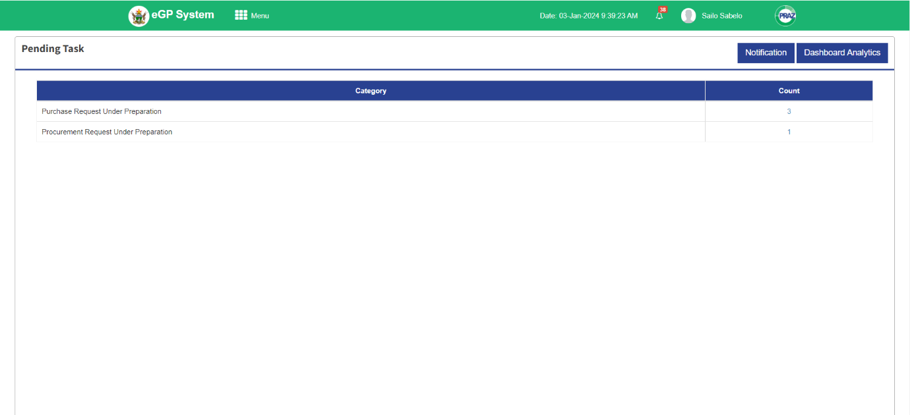**Step 1: Supplier** Log in to the system by selecting user type as supplier, username and password. The system directs the user to the dashboard with the pending task.

**Step 2:** Click **Menu** at the top left corner of the dashboard, the system responds with the Submenus for the Supplier.

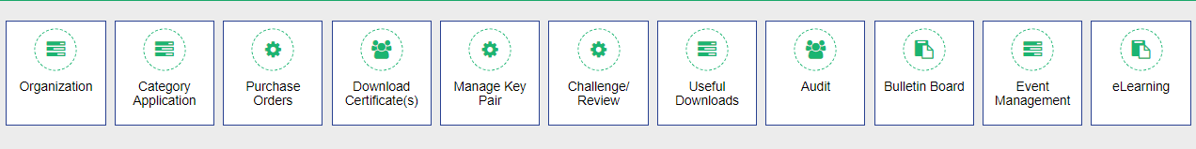

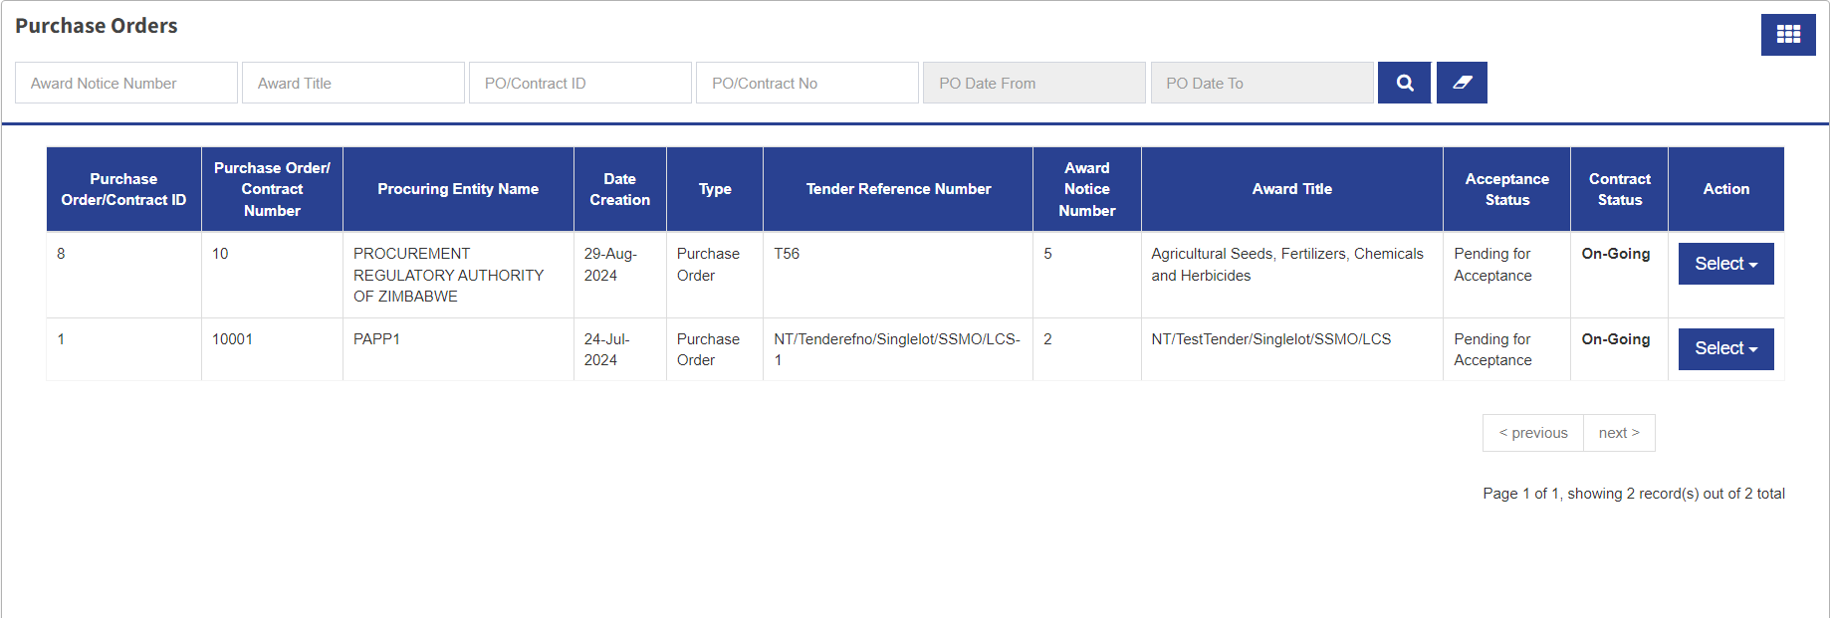**Step 3:** To proceed click **Purchase Orders**, the system responds with the list of contracts pending for Acceptance.

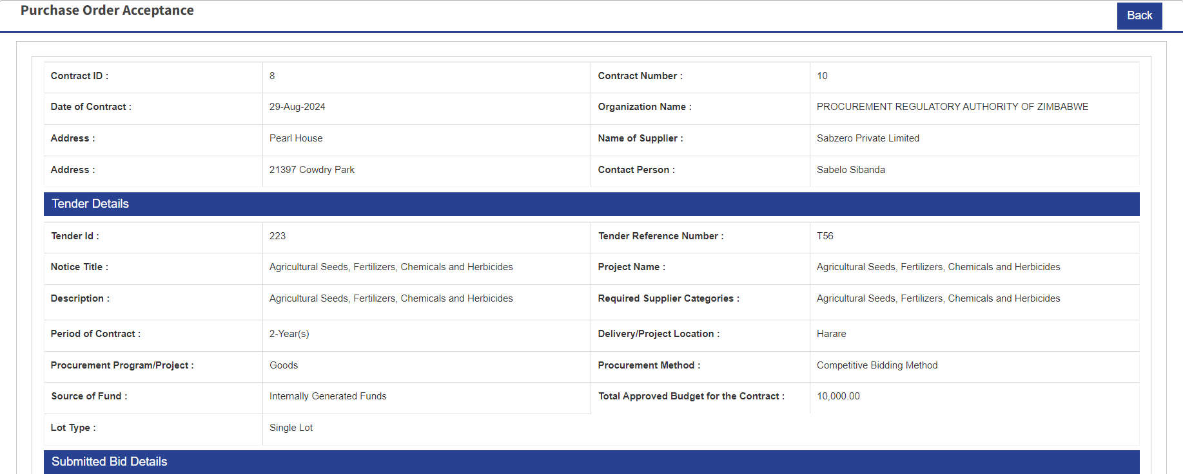**Step 4:** From the list of the contracts, choose the contract to accept and after that click **Select** dropdown the system responds with Accept Contract/PO. Click Accept Contract/PO the system responds with the Contract to be accepted by the supplier.

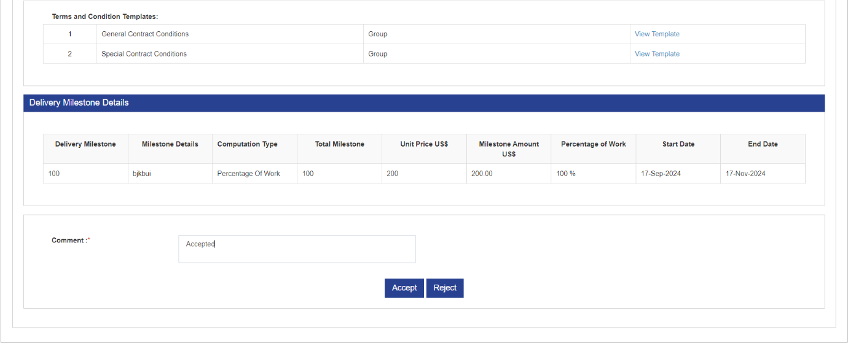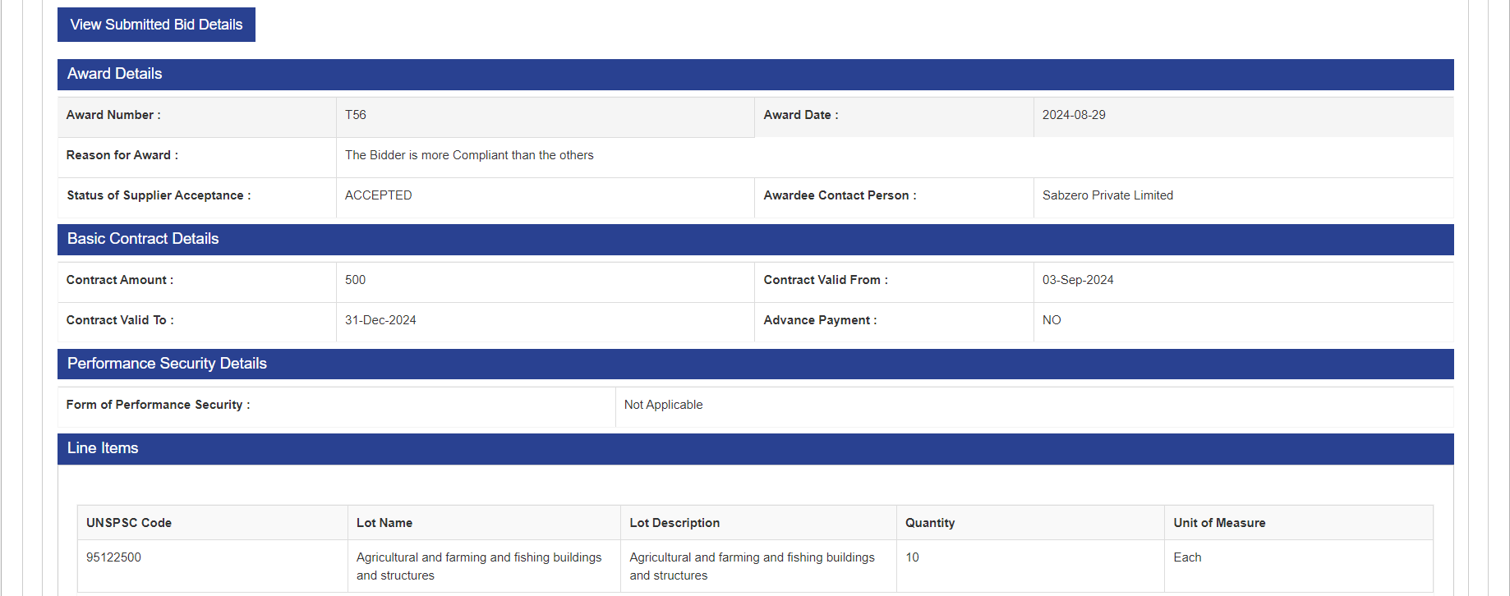

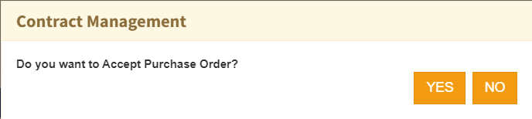**Step 5:** Go through all the contract terms and agreements from the Procuring Entity. If the Supplier is in agreement with the contract, then proceed by accepting the Contract. First put a comment and then click **Accept,** the system responds with the confirmation message “Do you want to accept Purchase Order?”

**Step 6:** If yes click YES and the system responds with the confirmation message “Purchase Order accepted successfully.”

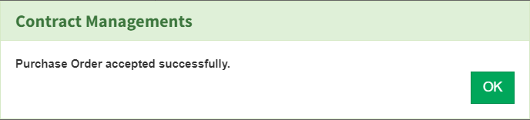

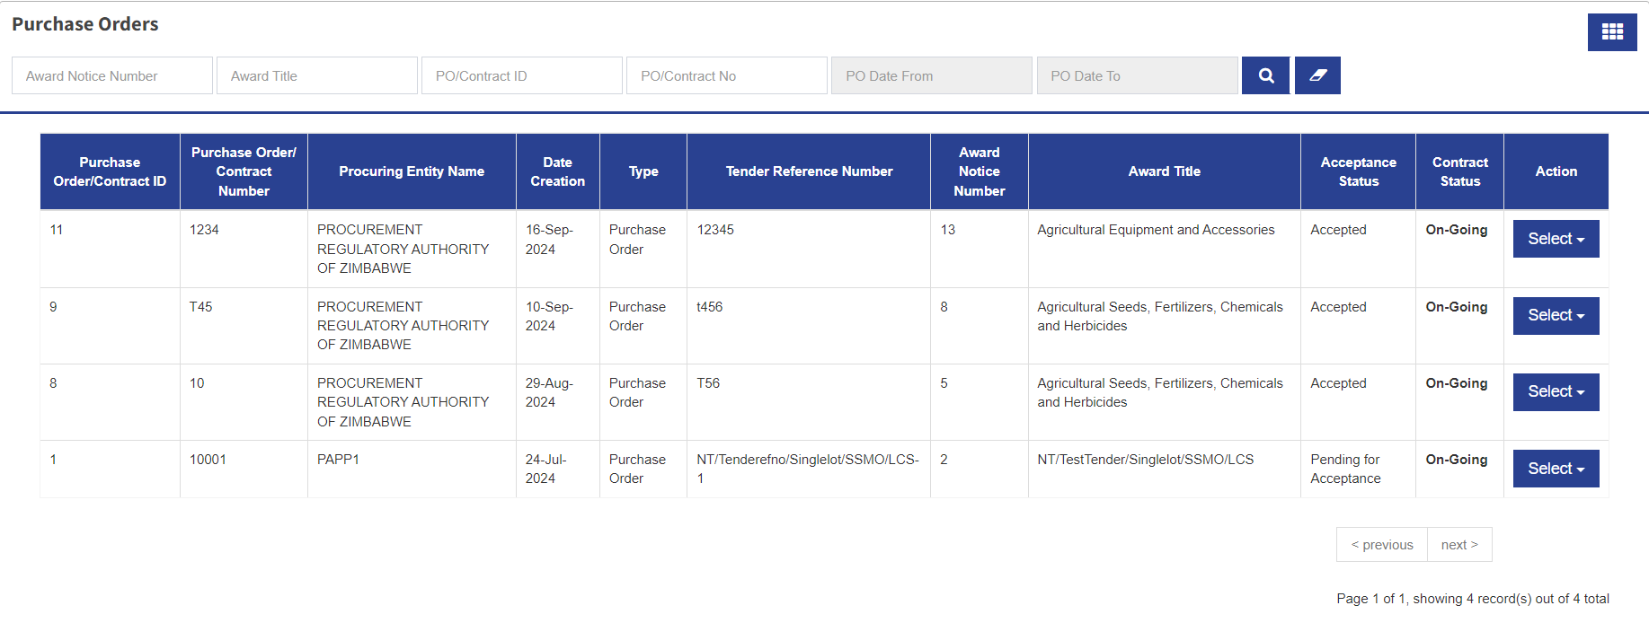**Step 7:** Once the message received, click OK and the system responds with purchase orders page with the status of the contract changes to Accepted.

**Step 8:** After Accepting the Supplier can logout waiting for the way forward from the PE.

………………………………………………………………….. The End ………………………………………………………………………